Instana Architecture
Instana uses single-agent architecture, which reduces server latency and achieves 1-seocnd data collection.
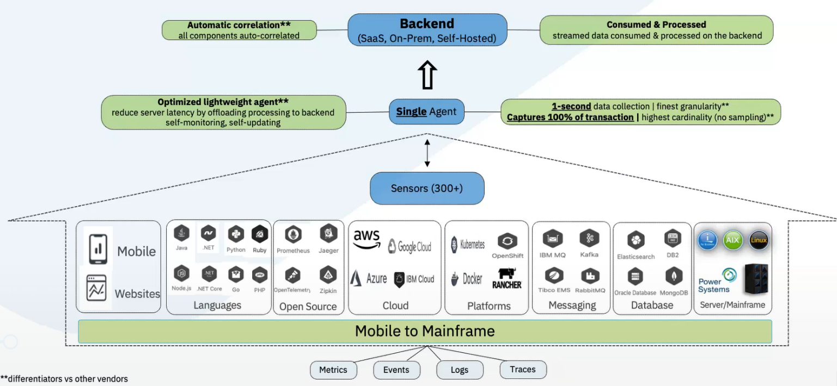
Instana agent automatically and continuously monitors the entire technology stack. The agent automatically deploys technology-specific sensors for all discovered technologies, which immediately begin sending the appropriate metrics back to the agent. The sensors also communicate with the agent about which tracers need to be injected, and all trace data is captured and then sent to the agent.

Instana backend is available as a SaaS solution with the option of retaining data in the cloud, or as a self-hosted (on-premises) solution.
3 major types of monitoring data are collected into the Instana backend, including beacons, traces, and metrics. Beacons are generated in the users’ web browser, traces are generated at the code level from monitored services, and time-series metrics are generated at the infrastructure level.
All data is streamed in real time to the Instana backend for analysis before it is sent to the data stores for long-term retention. The Instana agent resides outside of the application process and handles all communications with the Instana backend.
Access to the information that is stored in the Instana backend is handled either by the Instana web interface or by the Instana REST API.

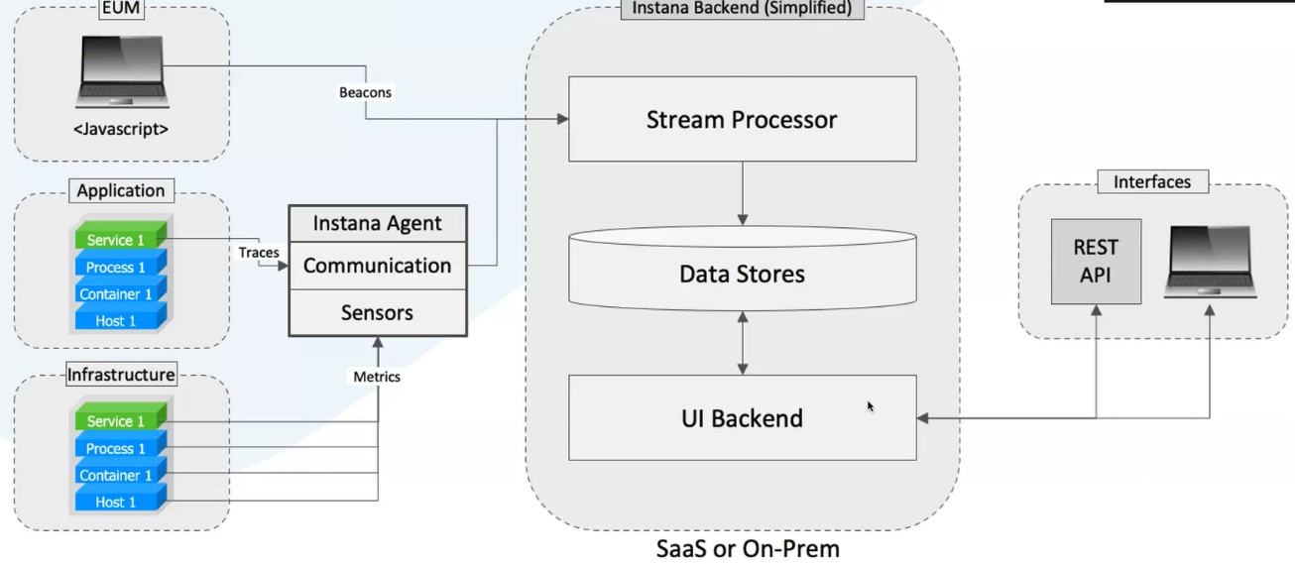
Data is streamed and processed in real time by parallel processors – providing immediate, exact understanding of the impact of any changes to the application such as code deployments, scaling up or down of resources. The processing is continuous, and it takes only a few seconds to fully process any collected data.
